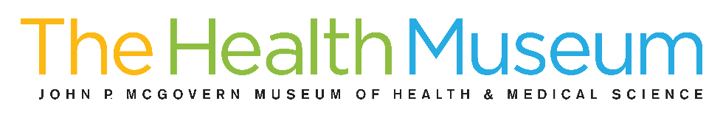
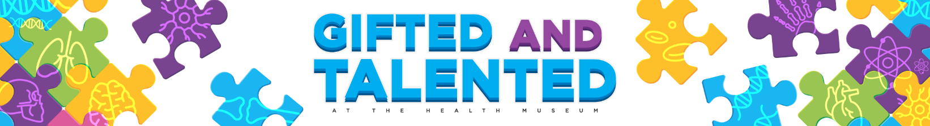
The gifted and talented program at The Health Museum consists of day-long courses that provide challenging, hands-on learning experiences.
These workshops promote creativity and critical thinking, while also allowing students to explore topics not typically covered in school.

SATURDAY'S 10:00 am - 2:00 pm
Ages 10-13
$120.00 per workshop

NOVEMBER 12, 2022

Surgeon for a Day
Learn about the different types of surgeons, participate in a fetal pig dissection, learn the basics of suturing and two-hand ties!

Biomedical Engineer for a Day
Is it possible to grow new organs in a test tube? Learn the fundamentals of biomaterials and how scientists work with cells and materials to design organs.

Pediatrician for a Day
Explore the field of pediatrics, the study of children and childhood diseases. From babies to teenagers, pediatricians take care of young people.

DECEMBER 10, 2022

Environmental Engineer, Marine Biologist, Cardiologist

JANUARY 14, 2023

Surgeon, Veterinarian, Genetics and Cancer Researcher

For more information visit https://www.thehealthmuseum.org/giftedandtalented

Ashley Alexander Education Program Specialist
713-521-1515 ext. 124
aalexander@thehealthmuseum.org

